HOURS – Sunday - Friday: 7AM-7PM  
  
X-Ray – Monday – Friday: 8am-6pm

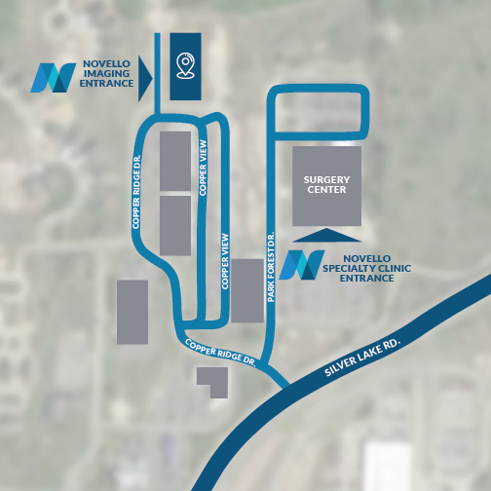

Sunday 7AM-7PM ONLY MRI appointments without contrast \*Last appointment 30 minutes before close  
  
NOVELLO IMAGING CENTER (BLDG F)  
1ST FLOOR BELOW WEST PRIMARY FRONT CARE  
4290 COPPER RIDGE DR, SUITE 100  
TRAVERSE CITY, MI 49684  
  
EMAIL  
info@novelloimaging.org  
  
CALL  
231.714.4306 (Phone)  
231.714.0077 (Fax)

Insurance Authorization can take up to 5-7 business days.

Novello Imaging will reach out to you once your order is processed to schedule your appointment.

.